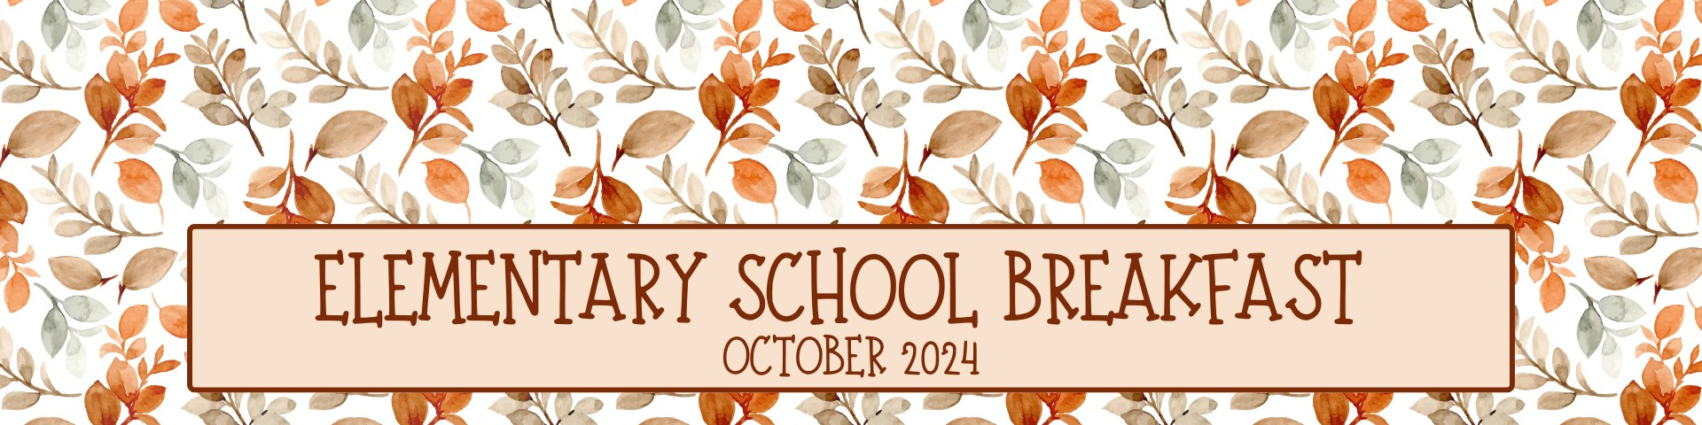

Monday | Tuesday | Wednesday | Thursday  Menu is subject to change and a variety of low fat or skim milk is offered daily, condiments offered daily, fruit & vegetable juices are 100% juice, grains are whole grain. | Friday
30  312 Fruit Loops Pouch  OR  315 Apple Cinnamon  Texas Toast  670 Fresh Fruit  748 Grape Juice  Pre-K: 341 Honey Bunches of  Oats Cereal  382 Cinnamon Toast Crunch  Bar BK Kit | 1  328 Chocolate Chip Muffin  OR  367 Cinnamon Raisin Bagel  648 Strawberry Gel Cup  749 Apple Juice  Pre-K: 332 Apple Cinnamon  Muffin  382 Cinnamon Toast Crunch  Bar BK Kit | 2  329 Honey Cheerios Cereal  OR  307 Cherry Frudel  750 Apple Juice  688 Orange Mango Applesauce  Pre-K: 368 Wheat Bagel  382 Cinnamon Toast Crunch  Bar BK Kit | 3  317 Confetti Mini  Pancakes  OR  922 Granola w/ Cinnamon & 138 Blueberry Yogurt  753 Orange Juice  659 Watermelon Craisins  Pre-K: 369 Mini French Toast  Berry Blasts  382 Cinnamon Toast Crunch  Bar BK Kit | 4  320 Corn Muffin  OR  364 Mini Cinni Pull-A-Part    670 Fresh Fruit  752 Fruit Punch Juice  Pre-K: 331 Corn Muffin  382 Cinnamon Toast Crunch  Bar BK Kit
7  334 Cinnamon Toast  Crunch Cereal  OR  137 Peach Yogurt & 922 Granola w/ Cinnamon  750 Apple Juice  670 Fresh Fruit  Pre-K: 327 Maple Mini  Waffles  380 Blueberry Pomegranate  Granola Bar BK Kit | 8  316 Eggo Maple Mini  Pancakes  OR  338 French Toast Sticks  657 Strawberry Craisins  752 Fruit Punch Juice  Pre-K: 341 Honey Bunches of  Oats Crunch  380 Blueberry Pomegranate  Granola Bar BK Kit | 9  323 Apple Cinnamon Muffin  OR  368 Plain Bagel  609 Mixed Fruit Cup  753 Orange Juice  Pre-K: 340 Honey Cheerios  380 Blueberry Pomegranate  Granola Bar BK Kit | 10  134 Cherry Vanilla Yogurt & 311 Apple Jacks Pouch  OR  365 Mini Cinni Caramel Pull-A-Part  670 Fresh Fruit  748 Grape Juice  Pre-K: 339 Orange Cranberry  Muffin  380 Blueberry Pomegranate  Granola Bar BK Kit | 11  308 Strawberry Mini Bagel  OR  317 Confetti Mini Bagels  Raisin Bagel  689 Strawberry Applesauce  749 Apple Cherry Juice  Pre-K: 346 Cinnamon Toast  Crunch Cereal  380 Blueberry Pomegranate  Granola Bar BK Kit
14  324 Cocoa Puffs Cup  OR  366 Blueberry Bagel  649 Orange Gel Cup  748 Grape Juice  Pre-K: 344 Rice Chex Cereal    390 Chocolate Chip Muffin  BK Kit  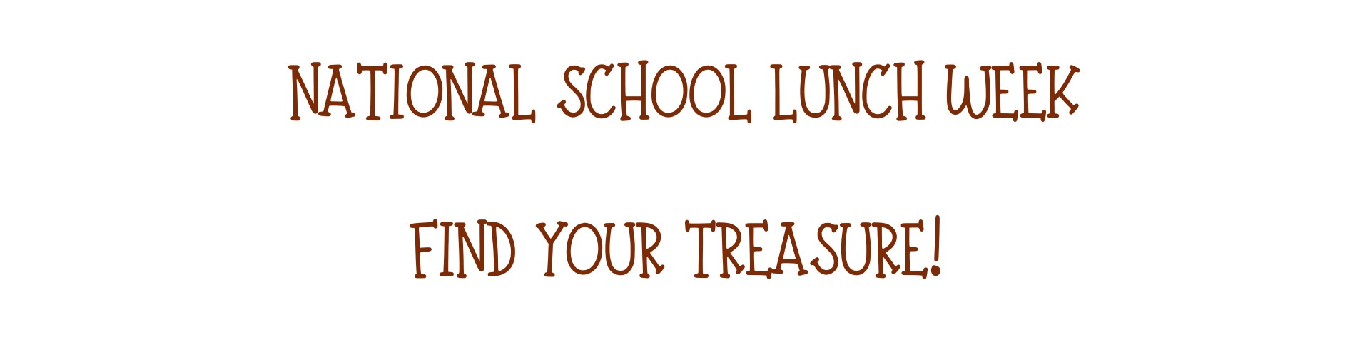 | 15  316 Maple Mini Pancakes  OR  307 Cherry Frudel  670 Fresh Fruit  750 Apple Juice  Pre-K: 331 Corn Muffin  390 Chocolate Chip Muffin  BK Kit | 16  328 Chocolate Chip Muffin  OR  327 Maple Mini Waffles  658 Cherry Craisins  752 Fruit Punch Juice  Pre-K: 341 Honey Bunches of  Oats Crunch  390 Chocolate Chip Muffin  BK Kit | 17  369 Mini French Toast  Berry Blast  OR  365 Mini Cinni Caramel  Pull-A-Part  697 Sliced Apples  749 Apple Cherry Juice  Pre-K: 332 Apple Cinnamon  Muffin  390 Chocolate Chip Muffin  BK Kit | 18  327 Eggo Maple Mini  Waffles  OR  329 Honey Cheerios Cup  670 Fresh Fruit  752 Orange Juice  Pre-K: 369 Mini French Toast  Berry Blast  390 Chocolate Chip Muffin  BK Kit
21  317 Confetti Mini Pancakes  OR  262 Turkey Sausage  Breakfast Pizza Bagel  658 Cherry Craisins  752 Fruit Punch Juice  Pre-K:  399 Cranberry Orange Muffin  385 Trix BK Kit | 22  319 Orange Cranberry  Muffin  OR  367 Cinnamon Raisin Bagel  670 Fresh Fruit  748 Grape Juice  Pre-K: 367 Cinnamon Raisin  Bagel  385 Trix BK Kit | 23  334 Cinnamon Toast Crunch Cup  OR  306 Apple Baked Frudel  644 Pear Cup  750 Apple Juice  Pre-K: 327 Maple Mini Waffles  385 Trix BK Kit | 24  308 Strawberry Mini Bagel  OR  311 Apple Jacks Pouch  & 136 Vanilla Yogurt  670 Fresh Fruit  753 Orange Juice  Pre-K: 340 Honey Cheerios  385 Trix BK Kit |   25  332 Apple Cinnamon  Muffin  OR  318 Cinnamon Mini  Waffles  670 Fresh Fruit  749 Apple Cherry Juice  Pre-K: 345 Honey Scooters  385 Trix BK Kit
28  324 Coco Puffs Cup  OR  138 Blueberry Yogurt  & 921 Granola  670 Fresh Fruit  750 Apple Juice  Pre-K: 346 Cinnamon Toast  Crunch  391 Blueberry Muffin BK Kit | 29  318 Cinnamon Mini Waffles  OR  321 Banana Muffin  608 Tropical Fruit Cup  753 Orange Juice  Pre-K: 369 Mini French Toast  Berry Blast  391 Blueberry Muffin BK Kit | 30  320 Corn Muffin  OR  369 Mini French Toast  Berry Blast  670 Fresh Fruit  749 Apple Cherry Juice  Pre-K: 339 Orange Cranberry  Muffin  391 Blueberry Muffin BK Kit | 31  351 Cinnamon Toast Crunch Bar  OR  316 Maple Mini Pancakes  657 Strawberry Craisins  748 Grape Juice  Pre-K: 341 Honey Bunches of Oats Crunch  391 Blueberry Muffin BK Kit | 1  327 Maple Mini Waffles  OR    315 Apple Cinnamon Texas Toast  670 Fresh Fruit  752 Fruit Punch Juice  Pre-K: 368 Wheat Bagel  391 Blueberry Muffin BK Kit

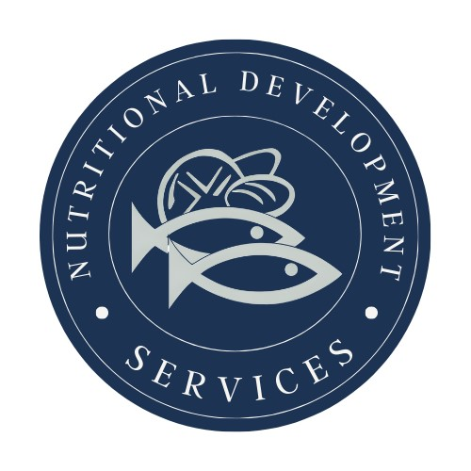
PLEASE READ CAREFULLY - Parents are strongly advised to review the menu completely to ensure that each of the food items is suitable for their children and will not trigger an allergic reaction or related illness. The Archdiocese of Philadelphia, Nutritional Development Services, Inc. and your children’s school shall not be responsible for any allergic reaction or related illness caused by any food item. Upon request and without charge, Nutritional Development Services will provide parents with information on any food item, which has been provided by the supplier of the food item. To request product information please call (215) 895-3470 during normal business hours.
Nutritional Development Services
Archdiocese of Philadelphia
222 N 17th St, Philadelphia, PA 19103
215-895-3470, option 1

