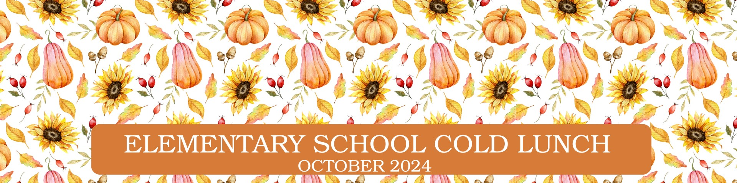
Menu is subject to change and a variety of low fat or skim milk is offered daily, condiments offered daily, fruit & vegetable juices are 100% juice, grains are whole grain.
Monday | Tuesday | Wednesday | Thursday | Friday
30  237 Italian Sandwich  620 Salsa  630 Dragon Punch Vegetable  Juice  658 Cherry Craisins  941 Tostito Scoops | 1  236 Turkey & Two Cheese  Wedge Sandwich  611 Bagged Carrots  534 Red Pepper Hummus  609 Dole Mixed Fruit Cup | 2  227 Turkey Ham, Turkey  Pepp & Cheese Sub  601 Homestyle Potato Salad  631 Cherry Star Vegetable  Juice  670 Fresh Fruit | 3  261 Soy Butter & Jelly  Sandwich  708 Spinach Salad w.  Chickpeas  670 Fresh Fruit OR  682 Bananas  932 Cinnamon Scooby Snacks | 4  229 Turkey Ham &  Cheese Croissant  622 Marinara Cup  634 Ruby Rusher Vegetable  Juice  670 Fresh Fruit    927 Cheddar Goldfish
7  237 Italian Sandwich  620 Salsa  632 Wango Mango  Vegetable Juice  648 Strawberry Gello Cups  941 Tostito Scoops | 8  233 Rotisserie Chicken &  Mozzarella on Broche Bun  602 PA Dutch Potato Salad  546 Cheesy Pizza Hummus  659 Watermelon Craisins  939 Heartzel Pretzels | 9  228 Turkey Ham &  Cheese Sub  708 Romaine Salad w.  Chickpeas  670 Fresh Fruit  937 Apple Cinnamon Bear  Grahams | 10  232 Buffalo Chicken &  Cheddar on Brioche Bun  611 Bagged Carrots  631 Cherry Star Vegetable  Juice  670 Fresh Fruit OR  682 Bananas | 11  229 Turkey Ham &  Cheese Croissant  621 Celery  634 Ruby Rusher Vegetable  Juice  543 Red Pepper Hummus  752 Fruit Punch Juice  932 Cinnamon Scooby Snacks
14  404 Italian Combo Wrap  620 Salsa    631 Cherry Star Vegetable  Juice  654 Raspberry Lemonade  Craisins    941 Tostito Scoops | 15  261 Soy Butter & Jelly  Sandwich  621 Celery  630 Dragon Punch Vegetable  Juice  749 Apple Cherry Juice  934 Dino Bites | 16  229 Turkey Ham &  Cheese Croissant  602 PA Dutch Potato Salad  634 Ruby Rusher Vegetable  Juice  670 Fresh Fruit  928 Goldfish Pretzels | 17  242 Chicken & Turkey  Ham & Cheese Wedge  Sandwich  611 Bagged Carrots  534 Red Pepper Hummus  609 Dole Mixed Fruit Cup  682 Banana | 18  232 Buffalo Chicken Breast  & Cheddar on Broche  Bun  708 Spinach Salad w.  Chickpeas    670 Fresh Fruit
21  233 Rotisserie Chicken &  Mozzarella on Brioche  Bun  601 Homestyle Potato Salad  631 Cherry Star Vegetable  Juice  670 Fresh Fruit  927 Cheddar Goldfish | 22  236 Turkey & Two Cheese  Wedge Sandwich  620 Salsa  633 Sunset Sip Vegetable  Juice  697 Bagged Apple Slices  941 Tostito Scoops | 23  227 Turkey Ham, Turkey  Pepp & Cheese Sub  611 Bagged Carrots  546 Cheesy Pizza Hummus  752 Fruit Punch Juice | 24  234 Turkey Ham & Two  Cheese on Roll  706 Romaine Salad w.  Cherry Tomatoes  670 Fresh Fruit OR  682 Bananas  931 Cinnamon Bug Bites | 25  228 Turkey Ham & Cheese  Sub  634 Ruby Rusher Vegetable  Juice  541 Chocolate Brownie  Hummus  648 Strawberry Gel Cup  929 Chocolate Tiger Bites
28  232 Buffalo Chicken Breast  & Cheddar on Broche  Bun  620 Salsa  630 Dragon Punch Vegetable  Juice  670 Fresh Fruit  941 Tostito Scoops | 29  261 Soy Butter & Jelly  Sandwich  621 Celery  633 Sunset Sip Vegetable  Juice  657 Strawberry Craisins  988 Cinnamon Graham Crackers | 30  238 Chicken Turkey  Pepperoni & Cheese  Croissant  611 Bagged Carrots  534 Red Pepper Hummus  750 Apple Juice | 31  404 Italian Combo Wrap  708 Spinach & Romaine  Salad w/ Chickpeas  670 Fresh Fruit OR  682 Bananas  993 Pumpkin Cookie | 1  227 Turkey Ham, Turkey  Pepp & Cheese Sub  634 Ruby Rusher Vegetable  Juice  602 PA Dutch Potato Salad  644 Pear Cup    936 Vanilla Bear Grahams

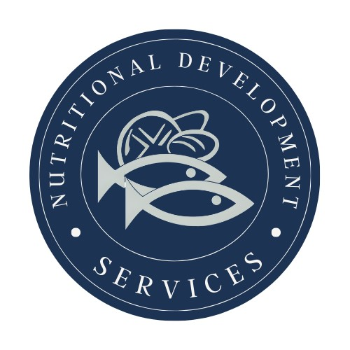
PLEASE READ CAREFULLY - Parents are strongly advised to review the menu completely to ensure that each of the food items is suitable for their children and will not trigger an allergic reaction or related illness. The Archdiocese of Philadelphia, Nutritional Development Services, Inc. and your children’s school shall not be responsible for any allergic reaction or related illness caused by any food item. Upon request and without charge, Nutritional Development Services will provide parents with information on any food item, which has been provided by the supplier of the food item. To request product information please call (215) 895-3470 during normal business hours.
Nutritional Development Services
Archdiocese of Philadelphia
222 N 17th St, Philadelphia, PA 19103
215-895-3470, option 1

