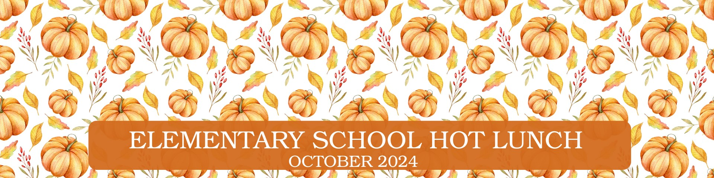

Monday | Tuesday | Wednesday  Menu is subject to change and a variety of low fat or skim milk is offered daily, condiments offered daily, fruit & vegetable juices are 100% juice, grains are whole grain. | Thursday | Friday
30  255 PizzaBoli  OR  203 Mini Pepperoni Calzone  OR  237 Italian Sandwich  620 Salsa  630 Dragon Punch Vegetable  Juice  658 Cherry Craisins  941 Tostito Scoops | 1  208 Mini Corn Dogs  OR  225 Ciabatta Cheese Melt V  OR  236 Turkey & Two Cheese  Wedge  611 Bagged Carrots  543 Red Pepper Hummus  609 Dole Mixed Fruit Cup | 2  226 Philly Cheese Steak  Pinwheel  OR  217 Spicy Grilled Cheese V  623 Tater Tots  631 Cherry Star Vegetable  Juice  670 Fresh Fruit | 3  221 Two Cheese, Chicken  Quesadilla  OR  274 Toasted Cheese Sandwich  OR  261 Soy Butter & Jelly  Sandwich  708 Spinach & Romaine Salad w.  Chickpeas  670 Fresh Fruit OR  682 Bananas  932 Scooby Snacks-Cinnamon | 4  264 4x6 Cheese Pizza V  OR  218 Mozzarella Pinwheel V    622 Marinara Sauce  634 Ruby Rusher Vegetable  Juice  749 Apple Cherry Juice  927 Cheddar Goldfish
7  205 Popcorn Chicken  OR  271 Cheeseburger Calzone  OR  232 Buffalo Chicken &  Cheddar on Brioche Bun  611 Bagged Carrots  543 Red Pepper Hummus  752 Fruit Punch Juice | 8  257 Mozzarella Sticks V  OR  210 Cheese Stuffed  Breadsticks V  OR  236 Turkey & Two Cheese  Wedge  622 Marinara Sauce  632 Wango Mango Vegetable Juice  649 Orange Gello Cups | 9  200 Hamburger  OR  201 Cheeseburger  OR  238 Chicken, Turkey Pepp  & Cheese Croissant  603 Baked Beans  634 Ruby Rusher Vegetable  Juice  670 Fresh Fruit | 10  268 French Bread Pizza V  OR  263 5” Round Cheese Pizza V  OR  233 Rotisserie Chicken &  Mozzarella on Brioche Bun  706 Romaine Salad w. Cherry  Tomatoes  670 Fresh Fruit OR  682 Bananas  932 Scooby Snacks-Cinnamon | 11  284 Chicken Alfredo, Penne  & Broccoli  OR  206 French Toast w. Sausage  623 Tater Tots  630 Dragon Punch Vegetable  Juice  659 Watermelon Craisins  909 Dinner Rolls
14  256 Cheese Stuffed Breadsticks & 934 Dino Bites  OR  288 Mac & Cheese w.  Broccoli V & 901 Honey  Biscuits  622 Marinara Sauce    630 Dragon Punch Vegetable Juice    654 Raspberry Lemonade Craisins | 15  215 Beef & Cheese Taco Stick  OR  221 Two Cheese Chicken  Quesadilla  620 Salsa  625 Corn  749 Apple Cherry Juice  941 Tostito Scoops | 16  206 French Toast w.  Sausage  OR  269 Pizza Calzone V  623 Tater Tots  634 Ruby Rusher Vegetable  Juice  670 Fresh Fruit  928 Goldfish Pretzels | 17  202 Cheeseburger w. Bun  OR  286 Penne w. Meat Sauce &  Cheese Veggies & 909  Dinner Roll  OR  242 Chicken Turkey Ham & Cheese Wedge Sandwich  611 Bagged Carrots  543 Red Pepper Hummus  670 Fresh Fruit OR  682 Bananas | 18  268 French Bread Cheese  Pizza V  OR  208 Mini Corn Dogs  OR  232 Buffalo Chicken &  Cheddar on Brioche Bun  708 Spinach & Romaine  Salad w. Chickpeas  609 Dole Mixed Fruit Cup  
21  272 Buffalo Chicken  Calzone  OR  225 Ciabatta Cheese Melt V  OR  233 Rotisserie Chicken &  Mozzarella on Brioche  Bun  620 Salsa  631 Cherry Star Vegetable Juice  670 Fresh Fruit | 22  257 Mozzarella Sticks V  OR  204 Chicken Nuggets  623 Tater Tots  633 Sunset Sip Vegetable Juice  697 Bagged Apple Slices  928 Goldfish Pretzels | 23  217 Spicy Grilled Cheese V  OR  226 Philly Cheese Steak  Pinwheel  OR  227 Turkey Ham, Turkey  Pepp & Cheese Sub  611 Bagged Carrots  546 Cheesy Pizza Hummus  752 Fruit Punch Juice | 24  207 Cheese Ravioli V  & 903 Maple Biscuits  OR  255 Pizzaboli V  OR  234 Turkey Ham & Two  Cheese on Roll  708 Spinach & Romaine  Salad w. Chickpeas  670 Fresh Fruit OR  682 Bananas | 25  281 Popcorn Chicken w/  Roasted Potatoes  OR  263 5’’Round Cheese Pizza V  & 632 Wango Mango  Vegetable Juice  541 Chocolate Brownie  Hummus  648 Strawberry Gello Cups  929 Chocolate Tiger Bites
28  205 Popcorn Chicken  OR  215 Taco Stick & 620 Salsa  Cup  623 Tater Tots  630 Dragon Punch Vegetable  Juice  670 Fresh Fruit  937 Apple Cinnamon Bear Grahams | 29  271 Cheeseburger Calzone  & 625 Corn & 988  Cinnamon Graham Crackers  OR  288 Mac & Cheese w.  Broccoli V & 909 Dinner  Rolls  633 Sunset Sip Vegetable Juice  657 Strawberry Craisins | 30  223 Veggie Pinwheel V  OR  203 Mini Pepperoni  Calzone  OR  238 Chicken, Turkey Pepp  & Cheese Croissant  611 Bagged Carrots  543 Red Pepper Hummus  687 Rosati “Chillin Bat” Ice | 31  264 4x6 Cheese Pizza V  OR  283 Chicken Tenders w/  Corn  OR  404 Italian Combo Wrap  708 Spinach & Romaine  Salad w. Chickpeas  670 Fresh Fruit OR  682 Bananas  933 Pumpkin Cookie | 1  210 Cheese Stuffed  Breadsticks V  OR  216 Spicy Taco Stick  622 Marinara Sauce  634 Ruby Rusher Vegetable    Juice  644 Dole Pear Cup  941 Tostito Scoops
V= Vegetarian Options
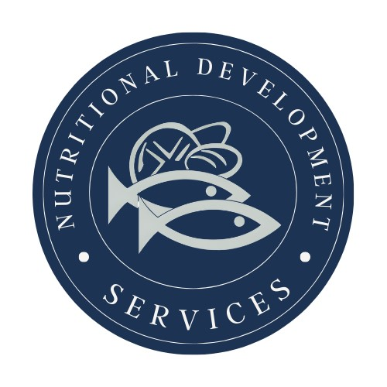
PLEASE READ CAREFULLY - Parents are strongly advised to review the menu completely to ensure that each of the food items is suitable for their children and will not trigger an allergic reaction or related illness. The Archdiocese of Philadelphia, Nutritional Development Services, Inc. and your children’s school shall not be responsible for any allergic reaction or related illness caused by any food item. Upon request and without charge, Nutritional Development Services will provide parents with information on any food item, which has been provided by the supplier of the food item. To request product information please call (215) 895-3470 during normal business hours.
Nutritional Development Services
Archdiocese of Philadelphia
222 N 17th St, Philadelphia, PA 19103
215-895-3470, option 1

Menu is subject to change and a variety of low fat or skim milk is offered daily, condiments offered daily, fruit & vegetable juices are 100% juice, grains are whole grain.
