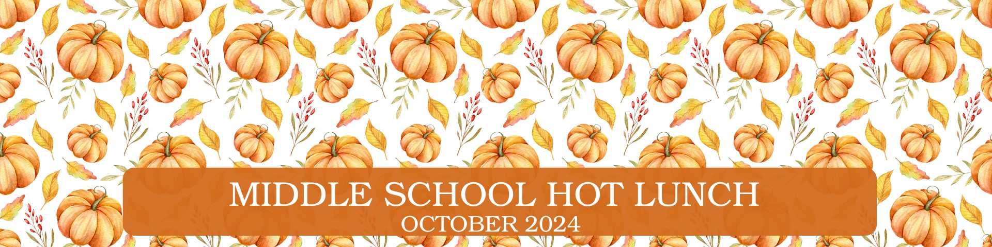
Menu is subject to change and a variety of low fat or skim milk is offered daily, condiments offered daily, fruit & vegetable juices are 100% juice, grains are whole grain.
Monday | Tuesday | Wednesday | Thursday | Friday
30  255 PizzaBoli V  OR  203 Mini Pepperoni Calzone  OR  268 French Bread Cheese Pizza V  OR  237 Italian Sandwich  620 Salsa  630 Dragon Punch Vegetable  Juice  658 Cherry Craisins  670 Fresh Fruit  941 Tostito Scoops | 1  208 Mini Corn Dogs  OR  225 Ciabatta Cheese Melt V  OR  236 Turkey & Two Cheese  Wedge  611 Bagged Carrots  543 Red Pepper Hummus  609 Dole Mixed Fruit Cup  670 Fresh Fruit | 2  226 Philly Cheese Steak Pinwheel  OR  217 Spicy Grilled Cheese V  OR  263 5” Round Cheese Pizza V  623 Tater Tots  631 Cherry Star Vegetable  Juice  670 Fresh Fruit  445 Mott’s Fruit Punch Juice | 3  221 Two Cheese, Chicken  Quesadilla  OR  274 Toasted Cheese Sandwich V  OR  261 Soy Butter & Jelly  Sandwich V  708 Spinach & Romaine Salad w.  Chickpeas  670 Fresh Fruit OR 682 Bananas  446 Mott’s Apple Juice  932 Scooby Snacks-Cinnamon | 4  264 4x6 Cheese Pizza V  OR  218 Mozzarella Pinwheel V    622 Marinara Sauce  634 Ruby Rusher Vegetable Juice  649 Orange Gel Cup  670 Fresh Fruit  927 Cheddar Goldfish
7  205 Popcorn Chicken  OR  271 Cheeseburger Calzone  OR  232 Buffalo Chicken &  Cheddar on Brioche Bun  611 Bagged Carrots  543 Red Pepper Hummus  670 Fresh Fruit  445 Mott’s Fruit Punch Juice  939 Heartzel Pretzels | 8  257 Mozzarella Sticks V  OR  210 Cheese Stuffed  Breadsticks V  OR  268 French Bread Cheese  Pizza  OR  236 Turkey & Two Cheese  Wedge  622 Marinara Sauce  632 Wango Mango Vegetable Juice  649 Orange Gel Cup  670 Fresh Fruit | 9  200 Hamburger  OR  201 Cheeseburger  OR  238 Chicken, Turkey Pepp  & Cheese Croissant  603 Baked Beans  634 Ruby Rusher Vegetable  Juice  670 Fresh Fruit  446 Mott’s Apple Juice | 10  268 French Bread Pizza V  OR  263 5” Round Cheese Pizza V  OR  264 4x6 Cheese Pizza V  OR  233 Rotisserie Chicken &  Mozzarella on Brioche Bun  706 Romaine Salad w. Cherry  Tomatoes  631 Cherry Star Vegetable  Juice  670 Fresh Fruit OR 682 Bananas  659 Watermelon Craisins  932 Scooby Snacks-Cinnamon | 11  284 Chicken Alfredo, Penne  & Broccoli V  OR  206 French Toast w. Sausage  623 Tater Tots  630 Dragon Punch Vegetable  Juice  659 Watermelon Craisins  670 Fresh Fruit  909 Dinner Rolls
14  210 Cheese Stuffed Breadsticks  & 934 Dino Bites  OR  288 Mac & Cheese w.  Broccoli V & 901 Honey  Biscuits  622 Marinara Sauce  630 Dragon Punch Vegetable  Juice    654 Raspberry Lemonade  Craisins  670 Fresh Fruit | 15  215 Beef & Cheese Taco Stick  OR  221 Two Cheese Chicken  Quesadilla  OR  263 5” Round Cheese Pizza V  620 Salsa  625 Corn  670 Fresh Fruit  445 Mott’s Fruit Punch Juice      941 Tostito Scoops | 16  206 French Toast w.  Sausage  OR  269 Pizza Calzone V  623 Tater Tots  634 Ruby Rusher Vegetable  Juice  670 Fresh Fruit  684 Mixed Berry Applesauce  928 Goldfish Pretzels | 17  202 Cheeseburger w. Bun  OR  286 Penne w. Meat Sauce & Cheese Veggies & 909 Dinner Roll  OR  264 4x6 Cheese Pizza V  OR  242 Chicken Turkey Ham &  Cheese Wedge Sandwich  611 Bagged Carrots  543 Red Pepper Hummus  670 Fresh Fruit OR 682 Bananas  446 Mott’s Apple Juice | 18  268 French Bread Cheese  Pizza V  OR  208 Mini Corn Dogs  OR  232 Buffalo Chicken &  Cheddar on Brioche Bun  708 Spinach & Romaine  Salad w. Chickpeas  633 Sunset Sip Vegetable Juice  609 Dole Mixed Fruit Cup  445 Mott’s Fruit Punch Juice
21  272 Buffalo Chicken Calzone  OR  225 Ciabatta Cheese Melt V  OR  233 Rotisserie Chicken &  Mozzarella on Brioche Bun  OR  268 French Bread Cheese Pizza  620 Salsa  631 Cherry Star Vegetable Juice  670 Fresh Fruit  445 Mott’s Fruit Punch Juice | 22  257 Mozzarella Sticks V  OR  204 Chicken Nuggets  623 Tater Tots  633 Sunset Sip Vegetable Juice  697 Bagged Apple Slices  693 Raspberry Lemonade  Sidekick  928 Goldfish Pretzels | 23  217 Spicy Grilled Cheese V  OR  226 Philly Cheese Steak Pinwheel  OR  264 4x6 Cheese Pizza V  OR  227 Turkey Ham, Turkey Pepp &  Cheese Sub  611 Bagged Carrots  630 Dragon Punch Vegetable Juice  546 Cheesy Pizza Hummus  654 Strawberry Craisins  670 Fresh Fruit | 24  207 Cheese Ravioli V  & 903 Maple Biscuits  OR  255 Pizzaboli V  OR  234 Turkey Ham & Two  Cheese on Roll  708 Spinach & Romaine  Salad w. Chickpeas  670 Fresh Fruit OR 682 Bananas  446 Mott’s Apple Juice | 25  281 Popcorn Chicken w/  Roasted Potatoes  OR  263 5’’Round Cheese Pizza V &  632 Wango Mango Vegetable  Juice  541 Chocolate Brownie  Hummus  648 Strawberry Gello Cups  670 Fresh Fruit  929 Chocolate Tiger Bites
28  205 Popcorn Chicken & 650  Strawberry Banana Smoothie Bowl  OR  215 Taco Stick & 620 Salsa  OR  268 French Bread Cheese Pizza  623 Tater Tots  630 Dragon Punch Vegetable  Juice  670 Fresh Fruit  937 Apple Cinnamon Bear  Grahams | 29  271 Cheeseburger Calzone  & 625 Corn & 988  Cinnamon Graham Crackers  OR  288 Mac & Cheese w. BroccoliV  & 909 Dinner Rolls  633 Sunset Sip Vegetable Juice  657 Strawberry Craisins  670 Fresh Fruit | 30  223 Veggie Pinwheel V  OR  203 Mini Pepperoni Calzone  OR  238 Chicken, Turkey Pepp  & Cheese Croissant  OR  263 5’’Round Cheese Pizza V  611 Bagged Carrots  632 Wango Mango Vegetable Juice  543 Red Pepper Hummus  687 Rosati “Chillin Bat” Ice  670 Fresh Fruit | 31  264 4x6 Cheese Pizza V  OR  283 Chicken Tenders w/ Corn  OR  404 Italian Combo Wrap & 546 Cheesy Pizza Hummus  708 Spinach & Romaine  Salad w. Chickpeas  670 Fresh Fruit OR 682 Bananas  445 Mott’s Fruit Punch Juice  933 Pumpkin Cookie | 1  210 Cheese Stuffed Breadsticks V  OR  216 Spicy Taco Stick & 620 Salsa  622 Marinara Sauce  634 Ruby Rusher Vegetable  Juice  644 Dole Pear Cup    670 Fresh Fruit  941 Tostito Scoops
V= Vegetarian Options
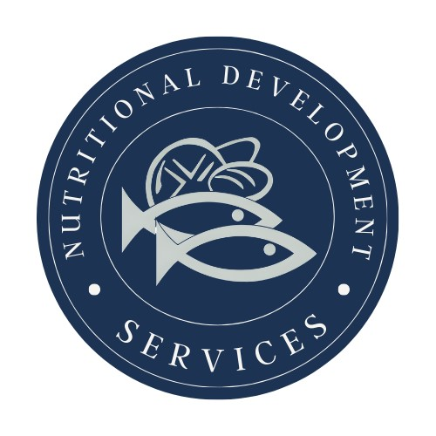
PLEASE READ CAREFULLY - Parents are strongly advised to review the menu completely to ensure that each of the food items is suitable for their children and will not trigger an allergic reaction or related illness. The Archdiocese of Philadelphia, Nutritional Development Services, Inc. and your children’s school shall not be responsible for any allergic reaction or related illness caused by any food item. Upon request and without charge, Nutritional Development Services will provide parents with information on any food item, which has been provided by the supplier of the food item. To request product information please call (215) 895-3470 during normal business hours.
Nutritional Development Services
Archdiocese of Philadelphia
222 N 17th St, Philadelphia, PA 19103
215-895-3470, option 1

