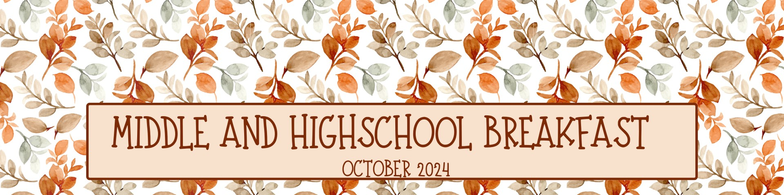

Monday | Tuesday | Wednesday | Thursday  Menu is subject to change and a variety of low fat or skim milk is offered daily, condiments offered daily, fruit & vegetable juices are 100% juice, grains are whole grain | Friday
30  312 Eggo Maple Mini  Pancakes  OR  315 Apple Cinnamon Texas  Toast  OR  316 Maple Mini Pancakes  670 Fresh Fruit  445 Mott’s Fruit Punch Juice  382 Cinnamon Toast Crunch  Bar BK Kit | 1  328 Chocolate Chip Muffin  OR  367 Cinnamon Raisin Bagel  OR  316 Maple Mini Pancakes  648 Strawberry Gel Cup  670 Fresh Fruit  382 Cinnamon Toast Crunch  Bar BK Kit | 2  329 Honey Cheerios Cereal  OR  307 Cherry Frudel  OR  316 Maple Mini Pancakes  446 Mott’s Apple Juice  688 Orange Mango Applesauce  382 Cinnamon Toast Crunch  Bar BK Kit | 3  317 Confetti Mini Pancakes  OR  922 Granola w/ Cinnamon  & 138 Blueberry Yogurt  OR  316 Maple Mini Pancakes  670 Fresh Fruit  659 Watermelon Craisins  382 Cinnamon Toast Crunch  Bar BK Kit | 4  320 Corn Muffin  OR  364 Mini Cinni Pull-A-Part  OR  316 Maple Mini Pancakes    670 Fresh Fruit  645 Pineapple Cup  382 Cinnamon Toast Crunch  Bar BK Kit
7  334 Cinnamon Toast  Crunch Cereal  OR  137 Peach Yogurt & 922  Granola w/ Cinnamon  446 Mott’s Apple Juice  670 Fresh Fruit  380 Blueberry Pomegranate  Granola Bar BK Kit | 8  316 Eggo Maple Mini  Pancakes  OR  338 French Toast Sticks  OR  329 Honey Cheerios Cereal  657 Strawberry Craisins  670 Fresh Fruit  380 Blueberry Pomegranate  Granola Bar BK Kit | 9  323 Apple Cinnamon Muffin  OR  368 Plain Bagel  OR  329 Honey Cheerios Cereal  609 Mixed Fruit Cup  670 Fresh Fruit  380 Blueberry Pomegranate  Granola Bar BK Kit | 10  134 Cherry Vanilla Yogurt  & 311 Apple Jacks Pouch  OR  365 Mini Cinni Caramel  Pull-A-Part  OR  329 Honey Cheerios Cereal  670 Fresh Fruit  445 Mott’s Fruit Punch Juice  380 Blueberry Pomegranate  Granola Bar BK Kit | 11  308 Strawberry Mini Bagel  OR  317 Confetti Mini Bagels  Raisin Bagel  OR  329 Honey Cheerios Cereal  689 Strawberry Applesauce  670 Fresh Fruit  380 Blueberry Pomegranate  Granola Bar BK Kit
14  324 Cocoa Puffs Cup  OR  366 Blueberry Bagel  OR  334 Cinnamon Toast  Crunch Cereal    649 Orange Gel Cup  670 Fresh Fruit  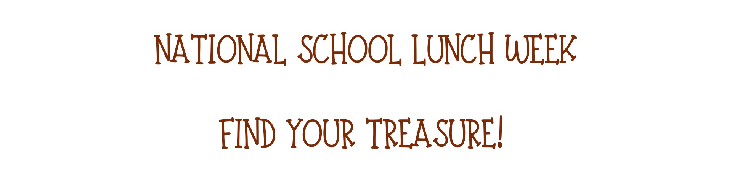  390 Chocolate Chip Muffin  BK Kit | 15  316 Maple Mini Pancakes  OR  307 Cherry Frudel  OR  334 Cinnamon Toast  Crunch Cereal  670 Fresh Fruit  445 Mott’s Fruit Punch Juice  390 Chocolate Chip Muffin BK  Kit | 16  328 Chocolate Chip Muffin  OR  327 Maple Mini Waffles  OR  334 Cinnamon Toast  Crunch Cereal  447 Mott’s Apple White Grape  Juice  752 Fruit Punch Juice  390 Chocolate Chip Muffin BK  Kit | 17  369 Mini French Toast  Berry Blast  OR  365 Mini Cinni Caramel  Pull-A-Part  OR  334 Cinnamon Toast  Crunch Cereal  697 Sliced Apples  446 Mott’s Apple Juice  390 Chocolate Chip Muffin  BK Kit | 18  327 Eggo Maple Mini  Waffles  OR  329 Honey Cheerios Cup  OR  334 Cinnamon Toast  Crunch Cereal  670 Fresh Fruit  688 Orange Mango  Applesauce    390 Chocolate Chip Muffin  BK Kit
21  317 Confetti Mini Pancakes  OR  262 Turkey Sausage  Breakfast Pizza Bagel  OR  328 Chocolate Chip Muffin  658 Cherry Craisins  670 Fresh Fruit  385 Trix BK Kit | 22  319 Orange Cranberry Muffin  OR  367 Cinnamon Raisin Bagel  OR  328 Chocolate Chip Muffin  670 Fresh Fruit  445 Mott’s Fruit Punch Juice  385 Trix BK Kit | 23  334 Cinnamon Toast Crunch Cup  OR  306 Apple Baked Frudel  OR  328 Chocolate Chip Muffin  644 Pear Cup  670 Fresh Fruit  385 Trix BK Kit | 24  308 Strawberry Mini Bagel  OR  311 Apple Jacks Pouch  & 136 Vanilla Yogurt  OR  328 Chocolate Chip Muffin  670 Fresh Fruit  648 Strawberry Gel Cup  385 Trix BK Kit | 25  332 Apple Cinnamon Muffin  OR  318 Cinnamon Mini Waffles  OR  328 Chocolate Chip Muffin  670 Fresh Fruit  447 Mott’s Apple White Grape Juice  385 Trix BK Kit
28  304 Cinnamon Frosted  Flakes Cup  OR  136 Vanilla Yogurt  & 921 Granola  OR  317 Confetti Mini Pancakes  670 Fresh Fruit  445 Mott’s Fruit Punch Juice  391 Blueberry Muffin BK Kit | 29  318 Cinnamon Mini Waffles  OR  321 Banana Muffin  OR  317 Confetti Mini Pancakes  608 Tropical Fruit Cup  670 Fresh Fruit  391 Blueberry Muffin BK Kit | 30  320 Corn Muffin  OR  369 Mini French Toast Berry  Blast  OR  317 Confetti Mini Pancakes  670 Fresh Fruit  446 Mott’s Apple Juice  391 Blueberry Muffin BK Kit | 31  351 Cinnamon Toast Crunch Bar  OR  316 Maple Mini Pancakes  OR  317 Confetti Mini Pancakes  657 Strawberry Craisins  670 Fresh Fruit  391 Blueberry Muffin BK Kit | 1  327 Maple Mini Waffles  OR  315 Apple Cinnamon Texas  Toast  OR  317 Confetti Mini Pancakes  670 Fresh Fruit  752 Fruit Punch Juice  391 Blueberry Muffin BK Kit

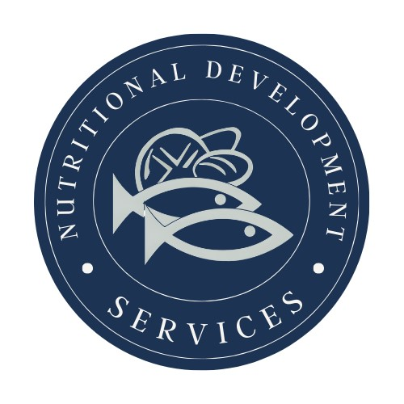
PLEASE READ CAREFULLY - Parents are strongly advised to review the menu completely to ensure that each of the food items is suitable for their children and will not trigger an allergic reaction or related illness. The Archdiocese of Philadelphia, Nutritional Development Services, Inc. and your children’s school shall not be responsible for any allergic reaction or related illness caused by any food item. Upon request and without charge, Nutritional Development Services will provide parents with information on any food item, which has been provided by the supplier of the food item. To request product information please call (215) 895-3470 during normal business hours.
Nutritional Development Services
Archdiocese of Philadelphia
222 N 17th St, Philadelphia, PA 19103
215-895-3470, option 1

